Clipboard Share

Clipboard Share is small utility that allows sending clipboard content from one computer to another. It is accessible through icon in system tray. User can send content of his clipboard to another user on another computer. The communication is encrypted and user can receive clipboard content from trusted senders only.

# License agreement

Copyright © 2010 Rasto Novotny

Permission is hereby granted, free of charge, to any person obtaining a copy of this software and associated documentation files (the "Software"), to deal in the Software without restriction, including without limitation the rights to use, copy, modify, merge, publish, distribute, sublicense, and/or sell copies of the Software, and to permit persons to whom the Software is furnished to do so, subject to the following conditions:

The above copyright notice and this permission notice shall be included in all copies or substantial portions of the Software.

THE SOFTWARE IS PROVIDED "AS IS", WITHOUT WARRANTY OF ANY KIND, EXPRESS OR IMPLIED, INCLUDING BUT NOT LIMITED TO THE WARRANTIES OF MERCHANTABILITY, FITNESS FOR A PARTICULAR PURPOSE AND NONINFRINGEMENT. IN NO EVENT SHALL THE AUTHORS OR COPYRIGHT HOLDERS BE LIABLE FOR ANY CLAIM, DAMAGES OR OTHER LIABILITY, WHETHER IN AN ACTION OF CONTRACT, TORT OR OTHERWISE, ARISING FROM, OUT OF OR IN CONNECTION WITH THE SOFTWARE OR THE USE OR OTHER DEALINGS IN THE SOFTWARE.

# Installation

Installation is either automatic via MSI package or manual. There are some prerequisites, however, before installation.

## Prerequisites

The application requires .NET 3.5 or higher version. It can be installed using Windows Update or Microsoft Update service. For details see documentation to your MS Windows. Or you can download .NET 3.5 installation from <http://www.microsoft.com/downloads/details.aspx?FamilyID=ab99342f-5d1a-413d-8319-81da479ab0d7>

To discover other computers with Clipboard Share utility it is required Peer Name Resolution Protocol (PNRP) installed and allowed in firewall. It is already installed in Windows Vista and higher versions and Windows Server 2008 and higher versions. It must be installed in Windows XP SP3 and Windows Server 2003. The installation is simple.

1. Open Control Panels.
2. Open Add or Remove Programs applet.
3. Choose Add/Remove Windows Components.
4. Find and open Networking Services.
5. Check Peer-to-Peer and click OK.
6. Click Next and complete installation.

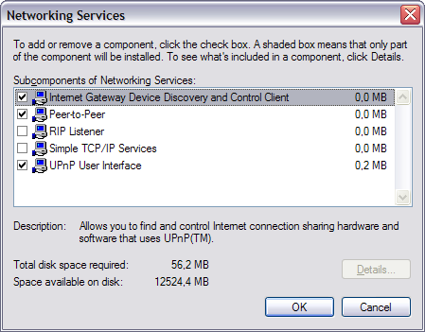

Application will be functional without PNRP, but list of available recipients would not be available and user must send clipboard content by typing computer name.

## Automatic installation

Download installation package (MSI) from [clipboardshare.codeplex.com](http://clipboardshare.codeplex.com). Run it and follow instructions on screen.

## Manual installation

Manual installation is very simple. Download ZIP package from [clipboardshare.codeplex.com](http://clipboardshare.codeplex.com). Extract the ZIP package. And run program ClipboardShare.exe.

# Sending of clipboard content

Primary function of this utility is to send content of clipboard to another user’s clipboard. This operation is very easy. Click the Clipboard Share icon in system tray and choose user to send the clipboard to. Every user is listed in format *computer_name*:*user_name*.

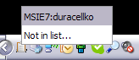

If user/computer is not in the list, then you can select **Not in list…** option. Then enter computer name and port of the remote user and click OK. Computer name and port must be specified in format *computer_name*:*port*. For example *msie7:54707*. How to determine port of your clipboard sharing program application is described in **Application settings** section.

You can check **Add permanently** checkbox to remember the address after application restart.

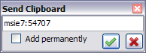

On another computer Clipboard Share application receive the clipboard content. If sender is authorized, then received content is automatically copied to user’s clipboard. If sender is not authorized, then user is asked to authorize the sender. User can accept or reject this sender.

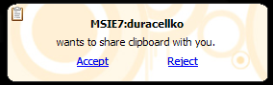

If user accepts the sender, then the sender is added to list of authorized senders and all his/her future contents are automatically copied to clipboard. List of authorized senders can be modified in **Application settings**.

## Default recipient

It is available to set default recipient. The advantage is that you can send clipboard to default recipient just by double-clicking the Clipboard Share icon in system tray. To set default recipient do the following:

1. Right-click the Clipboard Share icon in system tray.
2. Select **Set Default**.
3. And select computer/user to become default recipient.

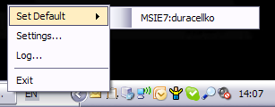

## Supported clipboard content

Not all content of clipboard can be sent via Clipboard Share utility. Supported types of content are:

* Plain text.
* Formatted text in Rich Text Format (RTF).
* Hyper-text markup language (HTML).
* Bitmap image.
* Device independent bitmap image.
* Vector image in Windows Metafile Format (WMF).
* Audio sample in WAV format.

# Application settings

To set up application right-click the Clipboard Share icon in system tray and select **Settings**. The dialog window contains 4 tabs.

## General settings

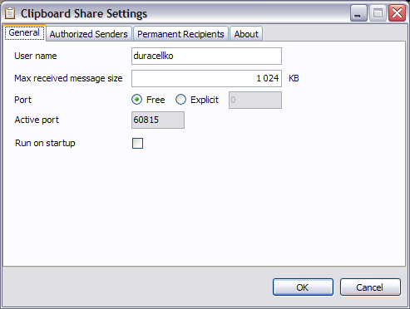

General settings are the following.

* **User name**: specifies, how you are displayed in list of recipients. Default setting is your Windows user name.
* **Max received message size**: specifies maximum size of clipboard content that can be received. The size is specified for encrypted format including signature.
* **Port**: Specifies TCP port of Clipboard Share service. Any free available port is used by default. It means that port is used dynamically and Clipboard Share uses different port after every application restart. It is possible to explicitly specify static TCP port. So it is used same port when application is started.
* **Active port**: determines port of your Clipboard Share application. Sender must use this port, when he/she wants to send you content by manually entering computer name and port.
* **Run on startup**: If checked, then Clipboard Share utility is started, when user logs on to Windows.

## Authorized senders

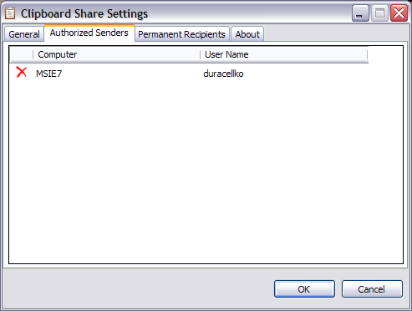

Authorized senders are users, which can send you clipboard content. Content from these users is automatically copied to clipboard without any user interaction. User becomes authorized, when you accept clipboard content from him/her.

At this tab it is possible to list authorized senders and delete them. By deleting user from this list, next received content from this user must be accepted or rejected.

## Permanent recipients

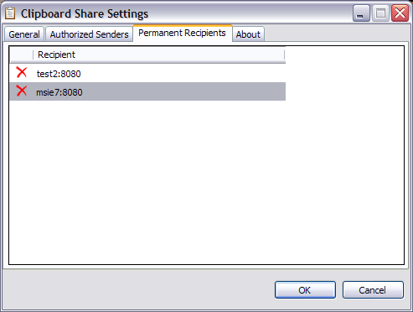

Permanent recipients tab contains list of addresses of Clipboard Share recipients. These addresses are shown in list of available recipients, even if not found on network. This is useful, if searching for Clipboard Share users on the network fails.

At this tab it is possible to list permanent recipients and delete them.

# Application log

Application log is list of errors and warning occurred in Clipboard Share application. Possible errors are for example:

* Clipboard content could not be sent, because remote computer could not be found.
* Clipboard content could not be sent, because its size exceeded maximum size set by remote user.
* Received clipboard content could not be decrypted or signature verified.

To display application log right-click Clipboard Share icon in system tray and select **Log…**.

# Errors and ideas

If you find any error or have a question or idea, please, feel free to submit it to <http://clipboardshare.codeplex.com/WorkItem/List.aspx>